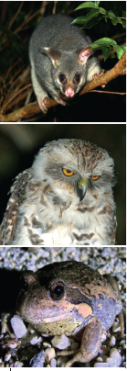
Carry out the following activities and send your entry to: info@ballaratobservatory.org.au with the Subject: IDSW Competition, with your name and contact details. The best entry will receive a 6” Dobsonian Reflector Telescope. All entries will be sent a discount code of 20% to visit the Observatory for one of our Nights Open during School Term 2021 or School Holiday Programs during 2021, for up to 2 Adults and 2 Students under 18yrs. Entries from Australia only and close 14th April 5pm. Winner announced and all notified by 20th April – Result published on https://ballaratobservatory.org.au/

How many animals and/ or insects can you count out and about after Dark? ………
List them………………………………………………………………………………………………………………
………………………………………………………………………………………………………………………..……
………………………………………………………………………………………………………………………………
Include images with your email if you have any.

Why do they need the dark?.....................................................................................
………………………………………………………………………………………………………………………………
…………….……………………………………………………………………………………………………………….

You might like to become a contributor on iNaturalist Australia and load your observations here:
https://inaturalist.ala.org.au/

If there is a clear night over the IDSW, how many stars can you count in the Southern
Cross?
3 4 5 6

Why can you see that many? ……………………………………………………………………………………………………………………
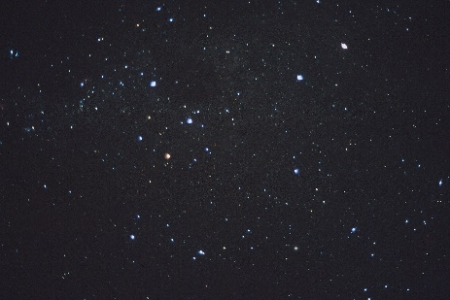
If you would like to add an observation to the Globe at Night Project, go to the website and state your observation number here ……………………….
https://www.globeatnight.org/webapp/

