Carry out the following activities and send your entry to: [info@ballaratobservatory.org.au](mailto:info@ballaratobservatory.org.au) with the Subject: IDSW Competition, with your name and contact details. The best entry will receive a pair of binoculars. Entries from Australia only and close 14th April 5pm. Winner announced and all notified by 20th April – Result published on <https://ballaratobservatory.org.au/>

How many animals and/ or insects can you count out and about after Dark? ………

List them………………………………………………………………………………………………………………

………………………………………………………………………………………………………………………..……

………………………………………………………………………………………………………………………………

Include images with your email if you have any.

Why do they need the dark?.....................................................................................

………………………………………………………………………………………………………………………………

…………….……………………………………………………………………………………………………………….

You might like to become a contributor on iNaturalist Australia and load your observations here:

<https://inaturalist.ala.org.au/>

If there is a clear night over the IDSW, how many stars can you count in the Southern Cross?

**3 4 5 6**

Why can you see that many? ……………………………………………………………………………………………………………………

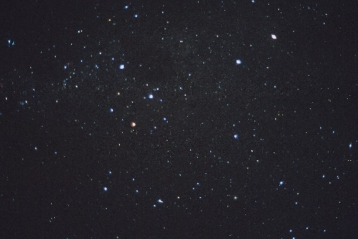Optional Activity:

If you would like to add an observation to the Globe at Night Project, go to the website and state your observation number here ……………………….

<https://www.globeatnight.org/webapp/>