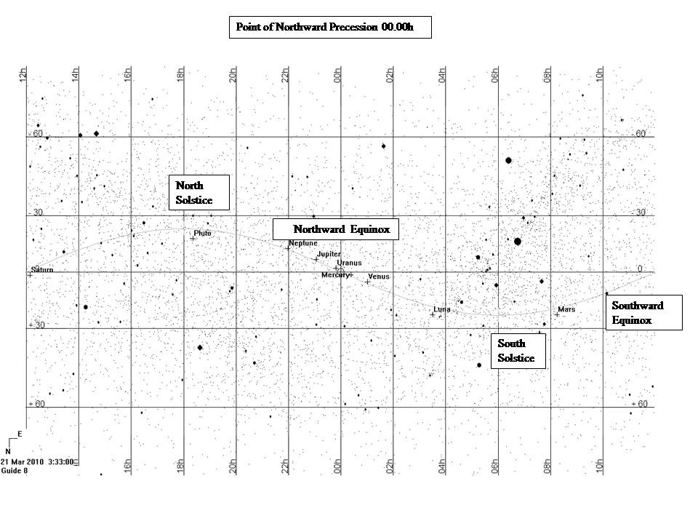

**Southward Equinox**

**North**

**Solstice**

**South Solstice**

**Northward Equinox**

Celestial Latitude

Celestial Longitude

Ecliptic- Path of Sun. Planets and Moon always very close

to the ecliptic.

Celestial

Equator

# Universal Nomenclature of the Equinoxes and Solstices

Figure 1 The positions of the planets, equinoxes and solstices for 21 March 2010 3.33 AEST

**Universal Nomenclature of the**

**Equinoxes and Solstices**

Each celestial object has coordinates similar

to a street directory to locate its’ position in

the heavens.

**Celestial Sphere** – An imaginary sphere surrounding the Earth on which the celestial bodies appear to lie.

**Celestial Longitude (CLong)** – coordinate

on the Celestial Sphere that corresponds to

the longitude on Earth and is measured

from 00.00h. Measured in hours, minutes, seconds or sometimes given as degrees,

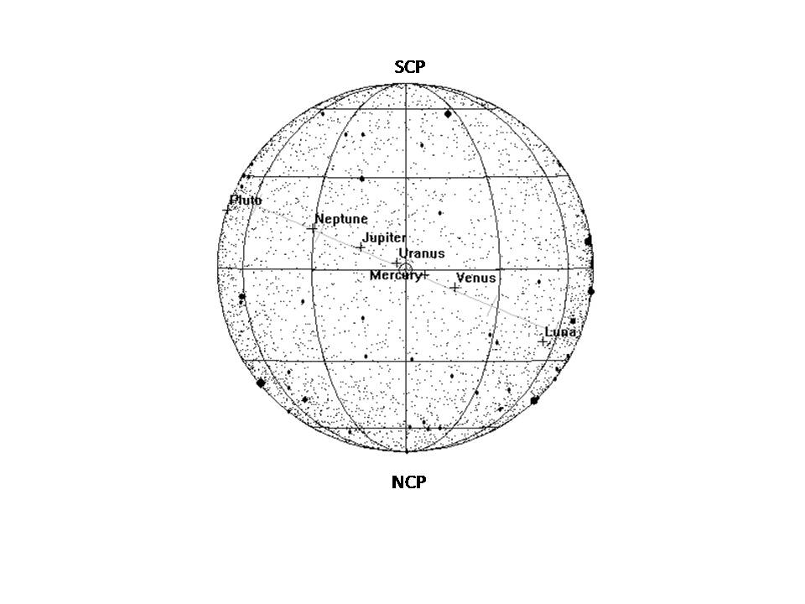minutes seconds corresponding to degrees

in a circle, ie 360 degrees.

**Celestial Latitude (CLat)–** corresponds to latitude on Earth’s surface and ismeasured

in degrees, minutes, seconds. Up to 90

degrees North (Nth) or South (Sth) of the Celestial Equator.

+ for the Northern Hemisphere,

– for the Southern Hemisphere.

**Celestial Equator** – directly above the

Equator on the Earth’s surface.

**Northward Equinox –** Day &Time the

Sun crosses the Celestial Equator travelling into the northern Hemisphere. 00.00h CLong

**North Solstice -** Date and Time Sun reaches its’ furthest northern position~ 23.5 degrees Nth. of the Celestial Equator.The Tropic of

Cancer on the Earth’s surface, northern limit

of Sun overhead.

**Southward Equinox -** Day and Time

Sun crosses the Celestial Equator travelling into the Southern Hemisphere.

**South Solstice -** Date and Time the Sun

reaches its furthest s outhern position~ 23.5 degrees Sth. of the Celestial Equator.

The Tropic of Capricorn on the Earth’s

Surface, southern limit of Sun overhead.

The preceeding 4 terms indicate:

1.Direction of the Earth’s Poles

relative to the Sun.

2.Extent of the Nth/Sth movement

of the Sun overhead

3.Direction of seasonal change of the

position of the Sun due to the angle of the

Earth’s axis of rotation, ~ 23.5 degrees.

**Ecliptic –** Path of the Sun against the background of the stars.

**SCP –** **South Celestial Pole**

**NCP -North Celestial Pole**

Both directly above the Earth’s Poles.

**The Point of Northward Precession –**

The point the Sun crosses the Celestial Equator travelling into the Northern Hemisphere. The point is actually moving 1/7 sec/day. It is linked to Celestial Longitude as the point slowly slips along the Celestial Equator.

**Epoch** For a printed map the stars positions are fixed and so the Epoch date needs to be stated, ie Current Epoch is 2000. Printed star maps are good for about 50 years, then the next epoch data is required for astronomers, ie next epoch will be 2050.

**Tropical Year** – Time for the Sun to travel from one Northward Equinox to next,

365.2422 days.

**Siderial Year –** Time taken for the Earth to complete one orbit relative to the fixed stars, 365.2564 days.

The difference between the Tropical and Siderial years is due to the effects of

precession, a gradual westward drift in the ecliptic. The gravitational pull of the Sun and Moon on the Earth’s equatorial bulge cause

the Earth’s axis to trace out a circle on the sky every 25,800yrs.

Judith Bailey – Ballarat Municipal Observatory & Museum

E: info@ballaratobservatory.org.au 0429 199 312

First printed 18.3.2010 Updated 20/7/2022